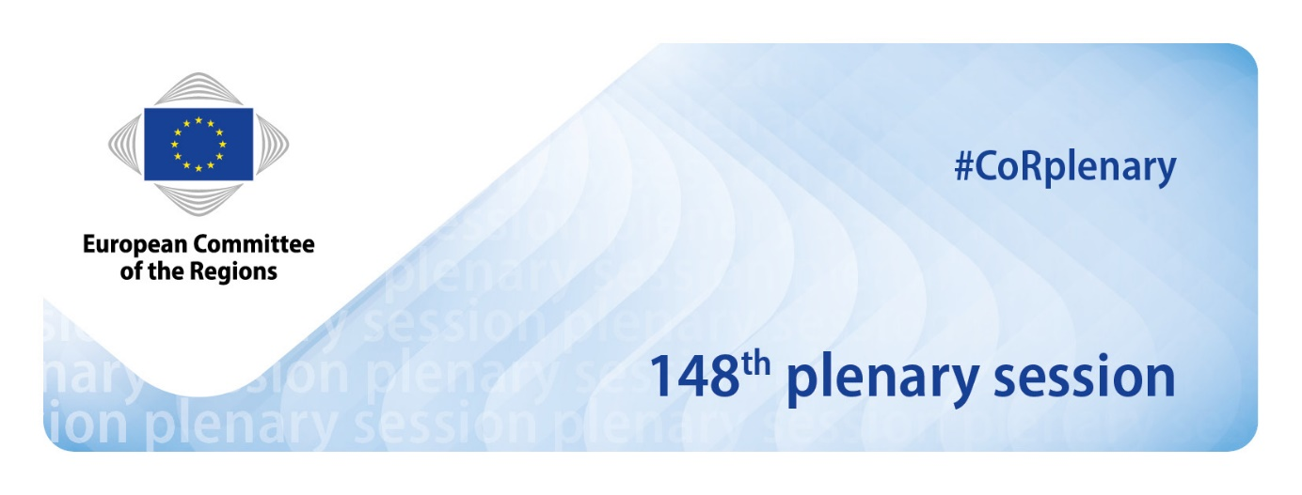
EN
Agenda

26-27 January 2022

Interpreting (passive: languages spoken):
BG-ES-CS-DA-DE-ET-EL-EN-FR-HR-IT-LV-LT-HU-MT-NL-PL-PT-RO-SK-SL-FI-SV-EU-CA
Interpreting (active: languages that can be listened to):
BG-ES-CS-DA-DE-ET-EL-EN-FR-HR-IT-LV-LT-HU-MT-NL-PL-PT-RO-SK-SL-FI-SV

IMPORTANT INFORMATION
- The plenary session will be fully remote.
- You are kindly requested to log in 15 minutes before the start of the session.

STRUCTURE OF THE JANUARY PLENARY SESSION

Wednesday, 26 January: Adoption of the final agenda – Statement by the president –Presentations and debates on draft opinions – Debate on EU matters for local and regional authorities – Debates – Votes on amendments and draft opinions.

Thursday, 27 January: Debates – Presentations and debates on draft resolution – Presentations and debates on draft opinions – Votes on amendments, draft opinions and resolution – End of the plenary session.

Wednesday, 26 January 2022

Debate on a long-term vision for rural areas
Statements by Dubravka ŠUICA, Vice-President of the European Commission,
Janusz WOJCIECHOWSKI, Commissioner for Agriculture
and Isabel CARVALHAIS, Member of the European Parliament
Wednesday, 26 January, 4-5.30 p.m.
____________________________________________________________________

Thursday, 27 January 2022

High level debate on cohesion implementation
Statements by Elisa FERREIRA, Commissioner for Cohesion and Reforms
and Lilyana PAVLOVA, Vice-President of the EIB
Thursday, 27 January, 9–10.30 a.m.

DEBATE ON EU Green Deal: Sustainable Smart Mobility in our regions, cities and villages
Statement by Adina VĂLEAN, Commissioner for Transport
Thursday, 27 January, 10.30–11.30 a.m.

MAYOR PAWEL ADAMOWICZ AWARD – CEREMONY AWARD
Statements by Vera JOUROVÁ, Vice-President of the European Commission,
Magdalena ADAMOWICZ, Member of European Parliament,
Henriette REKER, Mayor of Cologne,
Aleksandra DULKIEWICZ, Mayor of Gdansk,
and Christopher GRIBBLE, International Cities of Refuge Network (ICORN), Chair of board
Thursday, 27 January, 12 noon-1 p.m.

Debate with members of the CoFE Plenary Working Group on European Democracy
Statements by members of the COFE Working Group on European Democracy
Thursday, 27 January, 2.30–4 p.m.

Attention:
This is not the final agenda, which will be established by the Bureau on 25 January 2022
***
Document last updated: 04/02/2022
***
This document has been drawn up in accordance with Rule 15(3) of the Rules of Procedure and can be retrieved at: http://memportal.cor.europa.eu/Meeting/CommitteeAgenda
Wednesday, 26 January 2022

Adoption of the agenda (COR-2021-06050-00-04-CONVPOJ-TRA)

Approval of the minutes of the 147th plenary session, held on 1-2 December 2021

COR-2021-04683-00-00-PV-TRA – COR-2021-04683-00-00-PV-REF

COR-2021-04683-01-00-PV-REF – COR-2021-04683-02-00-PV-REF

COR-2021-04683-03-00-PV-REF – COR-2021-04683-04-00-PV-REF

COR-2021-04683-05-00-PV-REF – COR-2021-04683-06-00-PV-REF

Statement by the president

2.30 p.m. | PRESENTATION OF OPINIONS

Opinion on EU strategic framework on health and safety at work 2021-2027

own-initiative
COR-2021-05555-00-00-PAC-TRA – SEDEC-VII/024
Rapporteur: Sergio CACI (IT/EPP)

Local and regional authorities accelerating the implementation of the EU Pollinators Initiative

own-initiative
COR-2021-03508-00-00-PAC-TRA - ENVE-VII/020
Rapporteur: Frida NILSSON (SE/RENEW E.)

Statement by Martin HOJSÍK, Member of The European Parliament

3 p.m. | EU MATTERS FOR LOCAL AND REGIONAL AUTHORITIES

Statements by CoR members
COR-2021-06050-05-00-PSP-TRA

- Regions depending on the tourism sector: need to diversify the economy in the aftermath of the sanitarian crisis and in the light of climate challenges by Isilda Gomes (PT/PES)
- Strategic autonomy within the European Union - local and regional perspectives by Wladyslaw Ortyl (PL/ECR)

Debate with members of the European Committee of the Regions

4 p.m. | Debate on a long-term vision for rural areas

Statements by:
COR-2021-06050-02-01-PSP-TRA

- Dubravka ŠUICA, Vice-President of the European Commission
- Janusz WOJCIECHOWSKi, Commissioner for Agriculture
- Isabel CARVALHAIS, Member of the European Parliament

Debate with members of the European Committee of the Regions

5.30 p.m. | PRESENTATION OF 1 OPINION

A long-term vision for the EU's rural areas

own-initiative
COR-2021-03533-00-00-PAC-TRA – NAT-VII/021
Rapporteur: Juan Manuel MORENO BONILLA (ES/EPP)

5.40-6.30 p.m. | VOTING SLOT: ADOPTION OF 3 OPINIONS

6.30 p.m. | ADJOURNMENT

Thursday, 27 January 2022

9 a.m. | HIGH LEVEL DEBATE ON COHESION IMPLEMENTATION

Statements by:
COR-2021-06050-03-01-PSP-TRA

- Elisa FERREIRA, Commissioner for Cohesion and Reforms
- Lilyana PAVLOVA, Vice-President of the EIB

Debate with members of the European Committee of the Regions

10.30 a.m. | Debate on EU Green Deal: Sustainable Smart Mobility in our regions, cities and villages

Statement by Adina VĂLEAN, Commissioner for Transport
COR-2021-06050-04-01-PSP-TRA

Debate with members of the European Committee of the Regions

12 noon | MAYOR PAWEL ADAMOWICZ AWARD – AWARD CEREMONY

Statements by:

COR-2021-06050-06-01-PSP-TRA

Vera JOUROVÁ, Vice-President of the European Commission

Magdalena ADAMOWICZ, Member of European Parliament
- Henriette REKER, Mayor of Cologne
- Aleksandra DULKIEWICZ, Mayor of Gdansk
- Christopher GRIBBLE, International Cities of Refuge Network (ICORN), Chair of board

1-2.30 p.m. | BREAK

2.30 p.m. | Debate with members of the CoFE Plenary Working Group on European Democracy

Statements by members of the COFE Working Group on European Democracy
COR-2021-06050-07-01-PSP-TRA

- Reinhold LOPATKA, Member of the National Council of Austria
- Sandro GOZI, Member of the European Parliament
- Arnoldas PRANCKEVIČIUS, Vice-Minister of Foreign Affairs of the Republic of Lithuania
- Wepke Kingma, COFE Delegate for the Netherlands

Debate with members of the European Committee of the Regions

4 p.m. | PRESENTATION OF A RESOLUTION

Draft resolution on the contribution of the local and regional authorities to the Conference on the Future of Europe
COR-2021-06503-00-00-PRES-TRA – RESOL-VII/019

4.10 p.m. | PRESENTATION OF OPINIONS

Towards zero emission road transport: Deploying alternative fuels infrastructure and strengthening CO₂ emission performance standards

COR-2021-04913-00-02-PAC-TRA – COTER-VII/015

Rapporteur: Adrian Ovidiu TEBAN (RO/EPP)

Gender equality and climate change: towards mainstreaming the gender perspective in the European Green Deal

own-initiative
COR-2021-02509-00-00-PAC-TRA – ENVE-VII/018
Rapporteur: Kata TÜTTŐ (HU/PES)

EU Action Plan: Towards Zero Pollution for Air, Water and Soil
own-initiative
COR-2021-03178-00-00-PAC-TRA – ENVE-VII/019
Rapporteur: Marieke SCHOUTEN (NL/GREENS)

4.30–5.15 p.m. | VOTING SLOT: ADOPTION OF 3 OPINIONS AND 1 RESOLUTION

5.15 p.m. | other documents

Report on the impact of CoR opinions (COR-2021-05964-08-01-NB-TRA,

COR-2021-05964-08-01-NB-REF) (for debate)

Election of Bureau members (COR-2021-06050-00-00-PSP-REF) (for decision)

New CoR members and alternates (COR-2021-06050-00-00-PSP-TRA) (for information)

Any other business

Date of the next meeting

6.30 p.m. | END OF THE PLENARY SESSION

____________

Due to the current health situation in Belgium and following the opinion of the medical officer of the Committee, the plenary session will be held in full remote mode.
Simplified procedure.
Resolution submitted in accordance with Rule 45.3 b) of the Rules of Procedure.
Simplified procedure.

